EARLY YEARS
EXECUTIVE FUNCTION RESEARCH PROJECT
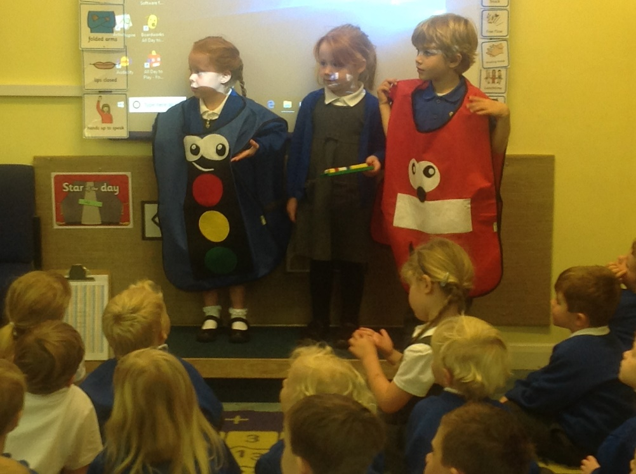
HOW DO WE DEVELOP AND EMBED
SELF-REGULATION?
- Introduction & Rationale
In 2017-18 four schools within Devon and Plymouth conducted a small-scale action research project investigating how a key aspect of executive function, self-regulation, might be explicitly explored with and taught to EY children. The findings of that first year are contained in a report ‘How do we develop self-regulation?’ The context related to small groups of children within each setting who it was felt would benefit from this approach, some of whom were used as controls. The outcomes, whilst having to be tentative due to the small numbers involved, were sufficiently strong to merit further research. It had also become clear that the raised awareness about self-regulation was impacting positively on other children and other staff on their learning. The focus for the second year therefore evolved into:
- maintaining the work on developing self-regulation but now in whole classes of children.
- the production of staff and parent training materials to support a more holistic approach for children’s self-regulation.
In the second year our research question was extended to become:
How do we develop and embed self-regulation in children?

- Involvement and Methodology
The following teachers and schools were involved in the project in its second year:
- Janice Harris (Assistant Head, SLE, Early Years Lead): Torrington Bluecoat Primary and Early Years Centre of Excellence.
- Lisa Broad (Early Years Lead, SLE) : St. Peters Primary, Budleigh.
- Keith Smithers (Early Years Lead, SLE) : Elburton Primary, Plymouth.

All teachers contributed to the design and development of the research.
A baseline was applied to all children within 7 classes in the Autumn of 2018. (2 Y1 classes and 2 Foundation classes in Torrington, 2 Foundation classes in Elburton and 1 Foundation class in St Peters. (In addition, Elburton used the approach to support a school wide self-relation approach to manging behaviours. No data was used to inform this aspect of their work but this will be available next year.) This was informed by a screen (developed from the work of Volckaerts), the Conners Behaviour Ratings scales, Leuvens scale of involvement, What to expect when? Guidance and Early Learning Goals. (See appendix 1) Baseline PSHE ELG assessments were also taken during the first half term. Both screens and ELG assessments were moderated during the summer term process on GLD.
It is recognised that in any small scale action research project and due to the nature of classroom research that findings will always need to be made tentatively and with the acknowledgement that other external factors are impossible to exclude.
- Developing Potential Strategies for Self-Regulation
During the first year the research group had developed a number of strategies to enable children to have greater understanding and ability to self-regulate. Importantly these broke down inhibitory controls into 4 different elements. The use of children’s language, characters and stories became a central vehicle to enable children to self-regulate and articulate their control.
- Characters
 | 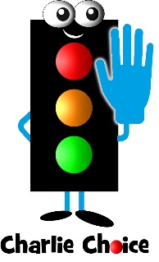 |  | 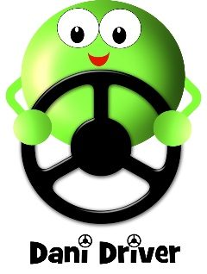
Inhibition of a Predominant Response  (Before it happens) | Interruption of an Ongoing Response  (During/whilst it is happening) | Managing External Distractors | Impulsivity Control Overall  (Reflecting after it has happened)

During the second year a new character, Robyn Repair was used to help develop children’s ability to find solutions to social difficulties, thereby enabling them to regulate their social behaviours in a more positive way.
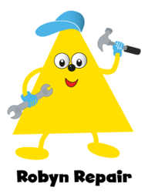
The following methods were used to explore self-regulation with he children:

- Stories linked to the characters to introduce them
- Gestures linked to the characters for ease of understanding eg:
Sammy Stop = hand up palm facing towards other person,
Charlie Choice = hands pam up ‘weighing the scales’
Freddie Focus = forefinger and thumb make a circle up against eye like a magnifying glass
Dani Driver = hands on steering wheel moving from side to side
Robyn Repair = two fists made, held at waist height with one lightly tapping on top of the other like a hammer.
- Stories that the children developed themselves with the characters based on their own experiences
- Pre-teaching using the characters and stories
- ‘In the moment’ responses / observations to the children’s play
- A variety of games : Buckaroo, Toilet Trouble, Snail’s Pace, Miss a Go, Goldilocks, Frozen, Simon Says, Spinner scenarios (options).
- Stroop Tests (eg a set of cards where there is a colour printed in words BLUE but it is actually coloured purple. Children have to say the actual colour - purple)
- Videoing children
- Small play with character puppets/ mini-me
- Children’s role play & Tabards of characters
- Children’s performance & freeze frame pictures – different choices
- Visual Learning environment – working wall/collective memories
- Safe places and de-escalation strategies
- Language of self-regulation
- Classroom culture of self-regulation

- Initial Findings and Data
- Baseline Screen (see appendix A

Children were screened against 19 separate areas of self-regulation in September 2018. These screens were revisited in June 2019. The improvements were very similar to the progress made by the smaller groups in the first year study. This would tend to suggest that the approaches taken were applicable to whole class exploration and teaching around self-regulation and achieved high impact when related to their PSE scores (below).

- Comparison with Prime Areas and Managing Feelings and Behaviour

- Some schools were able to make comparisons that linked the work they were doing around self-regulation to their end of EY assessments in ELGs/Prime Areas.
- Outcomes: following two terms work it is not possible to say that the work around self-regulation is having an impact yet on the prime areas of learning apart from in one case. Better impact were however shown in managing feelings and behaviour where all children had made progress.

School 1:
Area | Baseline  Average Score |  | June  Average score | June | Progress
Self-confidence/ managing behaviours and feelings/ making relationships | 5.8 | -0.2 | 9.4 | +0.2 | 3.4
The next highest progress score was +3.2 for reading and writing with all others below 3 indicating that this prime area of learning was the most improved during the year.
Moreover, the pupil premium children’s progress outperformed the rest of the class at +3.7
The gender gap also closed between boys and girls to 0.52

Area | Baseline  Average GLD | June  Average GLD | Progress
Self-confidence/ managing behaviours and feelings/ making relationships | 55% | 86% | +31%
Total GLD | 59% | 80% | +21%
PSE has outperformed other GLD area both in terms of attainment but also progress over the year.

School 2:
Area | Baseline  Average GLD | June  Average GLD | Progress
Self-confidence/ managing behaviours and feelings/ making relationships | 49% | 82% | +33%
Total GLD | 59% | 80% | +21%
PSED has outperformed other GLD areas both in terms of attainment but also progress over the year.

School 3
Area | Baseline  Average GLD | June  Average GLD | Progress
Self-confidence/ managing behaviours and feelings/ making relationships | 56% | 81% | +25%
Total GLD | 26% | 70% | +44%
PSED scores have made good progress over the year and have higher attainment than other areas. However, he remaining Prime Areas started off with a much lower entry level and have made greater progress.

- Case Studies

Case Study School 1
The main impacts seen through this second year have been:
- A high impact on children with ASD. They have found the really clear, explicit approaches much easier to understand. They have calmed more quickly when dysregulated. They have also made connections between the different areas through the very visual and physical approaches taken.
- One child has had the benefit of this approach over 2 years. He is managing his choices and feels ‘more secure in who he is’. His family feel he has made a lot of progress in PSED at home too. He has just had to move school and they have been really pleased with the way he has managed this process.
- Parents have found the characters very helpful , especially highly anxious parents as it gives them an approach to take with their children that is easy to understand.
- The children’s maps/ own stories they have remembered and keep going back to. It is hoped that if these and the approaches continue through school it will mean they don’t revert back to old behaviours
The challenges going into next year will be to ensure there is greater consistency across classes both in terms of moderating the screening baseline and outcomes as well as the approaches taken within classrooms.

Case Study School 2
The main impacts seen through this second year have been:
- The self-regulation screening provided a really helpful tool to analyse exactly what was happening for each child. This meant that all staff were aware and especially ‘in the moment’ knew how to support individuals. A good example of this was during a scooter experience day where 4 children were likely to find this day difficult in different ways. Through pre-emption, choices talked through with children, allowing children to find space and time to ‘get ready’ all had a very successful experience.
- The language of choice is much more prevalent with the children along with the ownership of their behaviours. An example: A Governor was observing within the Foundation unit where 2 children had a ‘falling out’. The Governor tried to intervene but one child said immediately ‘we don’t need adults, we’ve got to make our own choices’ They then proceeded to talk things through and agreed to cut in half what they were doing in order to share it.
The challenges for next year are to develop similar approaches in classes higher up the school. There are also staff changes and so training, especially for new Tas will be paramount in ensuring consistency of approach.
Case Study School 3
This school has developed whole school approaches as well as parental training. The main impacts seen through this second year have been:
- Learning walks have found a more consistent approach being taken across the school. This is especially true of the language being used across school, especially in the children owning their choices. KS2 do not use the characters but they do use the same language.
- Anecdotally this has also reduced lunchtime incidents. The school has now set up on their CPOMs system a way of monitoring this and so will be able to track and monitor impact in this way next year.
- Parents have particularly liked the approach towards a clear outlining/child understanding of choices. One parent has spoken of the difficulties around the ‘witching hour before bedtime’ when their child would often dysregulate. The simple language around stop and choice has helped the family through these periods t the extent that the child is now training the new puppy!
Challenges for next year are to embed fully the gains that have been made over this year and to monitor behaviours across the school.

- Next Steps
The EY Research group has no further funding to develop further the self-regulation or the 3rd strand of executive function: future planning. We will look for opportunities through the EEF to develop future projects within these areas. All teachers involved feel passionately that the approaches that have been taken really set strong foundations for children’s learning. The reports and materials developed have been the focus of a Devon-wide conference this year will be further disseminated through the DTSP website by publishing

- Training materials for Teachers and TAs
- Training materials for parents

- Reading and References we found helpful

Training Executive Function in Pre-schoolers | Alexandra Marie Volckaert | Trends in Neuroscience and Education 2015
Thinking Ahead about where something is needed: New Insights about episodic foresight in Preschoolers | Cristina Atance et al | Journal of Experiential Psychology 2015
Young Children’s Thinking About the future | Cristina Atance | Child Development Perspectives 2015
Interventions shown to Aid Executive Function Development in Children 4-12 years Old | Adele Diamond & Kathleen Lee | Science Magazine 2017
When Everything New is Well-Forgotten Old: Vygotsky/Luria Insights in the Development of Executive Functions | Elena Bodrova et al | New Directions for Child and Adolescent Development 2011

