Elburton Primary School
Effective Behaviours Policy
Adopted: March 2019 Review Date: March 2020

Introduction
The purpose of this core policy is to bring together all aspects of behaviour at Elburton Primary School, this includes the promotion of our learning behaviours across the school. It also links directly to the school’s ‘Anti-Bullying’ Policy, examples of good practice are contained within this policy. There are several appendices with this policy that support the implementation and ongoing effectiveness of the policy.

Aims
At Elburton Primary School we know that behaviour is closely linked to effective learning- a school with a rigorous, consistent and fair behaviour policy ensures that pupils are safe and that learning can take place effectively. We encourage an environment that enables all of our learners/pupils to learn and play in a safe, nurturing, respectful manner, and for our staff to be able to work in this way.

Elburton School has shared values regarding Behaviour- ‘Our School Charter’:

- Safe: A school where all feel safe and secure. A school where all take responsibility for their own actions and pride in all they do and how they present themselves to others.

- Pride: A school where we take pride in our active participation, aspiring to be the best we can be.

- Flourish: A school with high expectations for all its members who are encouraged to feel pride, self-respect and value differences. A school that empowers our children to thrive and make the right choices.

- Inspire: A school where we will inspire each other to become independent, self-motivated and confident. A school that defines clear and consistent guidelines of behaviour while promoting positive and fair expectations.

- Respect: A school which emphasises a collaborative approach to problem solving and communications are open and good, where all are considerate to one another listening, valuing and respecting the opinions of others.

Rationale
The premise behind our Effective Behaviours policy:
‘Thinking of a child as behaving badly which disposes you to think of punishment, thinking of a child as struggling to handle something difficult encourages you to help them through their distress.’

Strong relationships between staff, pupils and parents are vital. Staff must be fair and consistent with pupils (taking into account individual needs) and pupils need to understand that the staff member is in control at all times enabling pupils to feel safe. Equally staff must be approachable and there to help (not only there to discipline) and pupils must understand this. If a member of staff is having difficulties with an individual or group of pupils, they are to seek support in order to make a positive change.

This policy is developed to ensure guidance for the school community in order to promote positive and effective behaviour in the school. The procedures and guidance in this document provide a consistent approach across the whole school and enables pupils, parents and staff to understand the approaches to the management of behaviour in the school. It is also recognised that for some pupils, variance on these procedures will be made in order to meet and specific social, emotional, learning or other needs which will require a personalised approach which can be discussed with the class teacher or appropriate senior leader.

At Elburton Primary School, we know that behaviour is closely linked to effective learning - a school with a rigorous, consistent and fair behaviour policy ensures that pupils are safe, and that learning can take place effectively.
The school supports the pupils in self-regulating their behaviours.

We have identified that self-regulation is key in choosing effective behaviours for learning, therefore key words and characters are used to support and embed this across the school.

Foundation stage | Key Stage 1 | Key Stage 2
- Sammy Stop  - Charlie Choice  - Dani Driver  - Robyn Repair | - Sammy Stop  - Charlie Choice  - Dani Driver  - Freddie Focus  - Robyn Repair | - STOP  - CHOOSE  - REFLECT  - FOCUS  - REPAIR

Images to support self regulation:

We believe that each pupil and adult at Elburton has rights and responsibilities:

Rights | Responsibilities
We have the right to:  - Learn  - Be respected and treated fairly  - Be heard  - Feel safe | We have the responsibility to:  - Allow others to learn  - Respect others and treat them fairly  - Listen to others  - Keep others safe

Staff are entitled and expected to:

- Expect a safe and secure school environment conducive to effective and stimulating learning
- Work and teach throughout the day without undue disruption caused by pupil’s unacceptable behaviour
- Insist on high standard of acceptable behaviour from the pupils
- Encourage respect between pupils and proper respect for authority
- Prevent physical and verbal abuse between pupils in school
- Give priority to the needs of the majority of pupils, whilst at the same time recognising the needs of the individual child
- Identify the cause of a pupil’s unacceptable behaviour, help modify it and seek help and support from others in so doing
- Expect parents to help prepare their children to meet the school’s expectations and behave in ways acceptable to the school community
- Expect parents and staff to treat each other with mutual respect in all forms of communication
- Implement agreed sanctions when pupil’s behave in unacceptable ways, including exclusion from school in extreme circumstances

Parents are entitled to:
- The expectation that the school will maintain a safe and secure school environment conducive to effective and stimulating learning
- The school’s highest expectation of their potential for achievement in all areas of school life
- Regular information from and consultation with the school about their child’s progress and behaviour
- A clear set of guidelines and expectation about pupil’s behaviour in school
- A clear set of guidelines and expectation about pupil’s behaviour within school
- Early notification from the school of any problem with their child’s behaviour
- Expect parents and staff to treat each other with mutual respect in all forms of communication

- Opportunities to help the school address their child’s behaviour problems

Rewards and Consequences
Rewards | Consequences
- Verbal praise  - Written praise in books  - Class jar  - Heads certificates and leaf to go on the ‘Leaf for learning tree’  - Star learning to be celebrated on learning walls or achievement boards.  - F/KS1- daily star learners with an overall weekly star- certificate to be given out.  - KS2- weekly star learners.  - Star attitudes to be celebrated- linked to termly focus on a learning behaviour/attitude. | - A ‘look’ to indicate the child is not following the class, school expectations.  - A ‘discussion’ between the child and member of staff- ensuring clarity of expectation and support for making the right choice.  - Freddie Focus time- in class, in safe space or in buddy class. (picture of Freddie focus).  - Communication with home- image of telephone. Recorded on CPOMS.  - Involvement with senior leadership team- picture of them.  - Repair time  If the behaviour is ongoing- refer to the ’Ongoing Behaviour Section’ in the appendices.
Play and lunch times
Rewards | Consequences
- Stickers- specific reason given to the children for the sticker. Children who receive a sticker put something in the class jar.  - Positive affirmations for the behaviours they are demonstrating. | - A ‘look’ to indicate the child is not following the school expectations.  - A ‘discussion’ between the child and member of staff- ensuring clarity of expectation and support for making the right choice.  - Time out with key person or member of SLT for set time  - Communication with home- image of telephone. Recorded on CPOMS.  - Involvement with senior leadership team- picture of them.

Minor and Major Incidences
Minor incidents might include:
- Talking at inappropriate times
- Mistreating school or other property
- Distracting other pupils
- General behaviour around the school, eg running in the corridors, talking in assemblies
- Not having the correct uniform to enable them to learn, eg PE kit
- Isolated shouting out
- Not completing sufficient learning
- Lack of co-operation with peers
Major incidents might include:
- Any prejudice-based comments eg racist/homophobic/transphobic/religious/gender
- Verbal/written comments, swearing, making comments intended, or likely, to cause upset or offence to someone else
- Theft
- Vandalism of anybody’s property
- Physical
- Play fighting/rough play
- Exclusion of peers from games, if intended to cause upset to them
- Defiance after a reasonable request has been specifically directed at the individual by an adult
- Bringing in inappropriate items
- Ongoing multiple issues in a day

Persistent ongoing issues
In all cases where the behaviour is a significant cause for concern a Behaviour Plan is completed. This is circulated among leadership team, teaching teams and lunchtime support ensuring all are aware of the expectations. This will be monitored and reviewed at regular intervals- refer to the flow chart below.

Internal Exclusion
Due to behaviour of a child it might be necessary to have an internal exclusion, parents will be informed of this before it happens. The child will complete the same learning as those in class and will be supervised by a member of staff.

Fixed Term and Permanent Exclusions
Only the Headteacher (or the acting headteacher) has the authority to exclude a pupil from school. The headteacher may exclude a pupil for one or more fixed periods, for up to 45 days in any one school year. The Headteachers may also exclude a pupil permanently. It is also possible for the Headteacher to convert a fixed term exclusion into a permanent exclusion, if the circumstances warrant this.

If the Headteacher excludes a pupil, the parent is informed immediately, giving reasons for the exclusion. At the same time, the Headteacher makes it clear to the parents that they can, if they wish, appeal against the decision to the governing body. The school will inform the parent how to make such an appeal.

The Headteacher informs the LA/CEO of Horizon and the governing body about any exclusions. The governing body cannot either exclude a pupil or extend the exclusion period made by the Headteacher. The governing body has a discipline committee that is made up of three members- the committee considers any appeals on behalf of the governors. When an appeals panel meets to consider an exclusion, they consider the circumstances in which the pupil was excluded, consider any representation by parents and the LA and consider whether the pupil should be reinstated. If the governors’ appeal panel decides that a pupil should be reinstated, the Headteacher, must comply with this ruling.

Monitoring
The Headteacher and a member of the SLT monitors the effectiveness of this policy on a regular basis. This is reported to the governing body at regular intervals, and if necessary, makes recommendations for further improvements.

The school keeps a record of incidences of misbehaviour on CPOMS- the class teacher records minor classroom incidences. Incidences at lunchtime are closely communicated by the MTAs to the class teacher or to main person on SLT for that day.

It is the responsibility of the governing body to monitor the rate of internal exclusions and fixed term exclusions, and to ensure the policy is implemented fairly and consistently.

Review
The governing body reviews this policy every year, however it can be reviewed earlier if needed, due to government regulations or recommendations to the policy.

Appendix 1
PACE in Action
“An attitude of stance of Playfulness, Acceptance, Curiosity and Empathy: qualities that are helpful when creating emotional safety and when trying to stay open and engaged with another person. This, in turn, helps the other person stay open and engaged with you. These traits are similar to the attitude that parents routinely show when communicating with infants.”
Dan Hughes 2017

P - PLAYFULNESS | A - ACCEPTANCE
- Dampens stress and fear, as playfulness can enable the child to become used to positive emotion.  - The part of the brain activated during laughter is different to the part activated when experiencing shame, therefore a sense of humour is protective.  - Encourages safe exploration | - Demonstrating that you are accepting them, including their challenges, needs and what stage they are at.  - Communicating acceptance and warmth by engaging rather than avoiding or rejecting of them: being physically and emotionally present.  - By feeling accepted, the child can stay regulated and avoid feeling shame- this means that they’re able to learn from their experiences.
In action:  Be involved with the child’s interests;  Show delight and enjoyment;  Follow-lead-follow;  Keep interactions light and avoid questions;  Use humour carefully. | In action:  Stay with their comfortable feelings;  Provide commentaries;  Opportunities for being quiet;  When safety become a priority, increase structure, boundaries and direction as needed.

Examples:
Playfulness: ‘I like the way you’re building that tower... you seem to really enjoy using the different materials...”
“I am following you and you’re showing me how to do this, thank you...”
“This is so much fun, I am enjoying time with you...”
Acceptance:
“I can see you’re not feeling so good right now and that it’s really hard for you to feel calm...”
“I will keep you and the other children safe.”

C - CURIOSITY | E - EMPATHY
- This shows the child that you’re interested, therefore helping to enhance their own curiosity about themselves.  - Less likely to make them defensive, gets through to the child in a way that anger cannot. | - Showing the children that ‘you get it’, you’re sharing whatever emotion they might be experiencing.  - Showing them that you’re not overwhelmed by that emotion and that you can manage it.  - Creating a new meaning and seeking repair, can help the child to move out of shame.
In action:  Wonder aloud and notice feelings;  Recognise positive qualities;  Model thinking, noticing, making sense of cause and effect;  Stress scaling when arousal levels are low;  Create a narrative for the child. | In action:  Be patient, remain calm and attuned;  Name ad explore feelings;  Provide validation;  Saying aloud your best guesses for how they are feeling, without expecting a response.

Examples:
Curiosity: Wondering: “You say you are fine but it looks as you have been crying - I wonder what has happened”, “I notice when you...”
Describe what you are seeing, “You are shivering but you don’t seem to realise you are cold!”
Empathy:
“You really wanted to see the play and you’re angry with me because I said you could not go. I understand your anger since you want to see the play so badly! It must be so disappointing that you can’t go with your class.”
“I can see that it’s tough because you don’t trust grown-ups, but we’ll work on that together.”

Appendix 2
For ongoing issues, the flow chart below needs to be followed, as a clear guide. In all cases where the behaviour is a significant cause for concern, and it is ongoing, it will be logged on CPOMS and a behaviour plan set in place. The template for a behaviour plan is in the appendices - a record of this should be developed and agreed in partnership with the child, parent, class teacher and member of SLT.
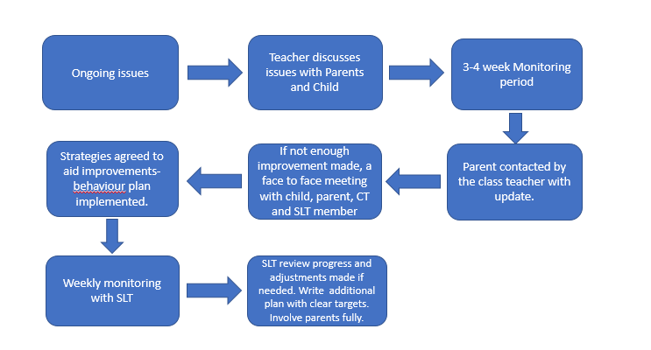
Appendix 3

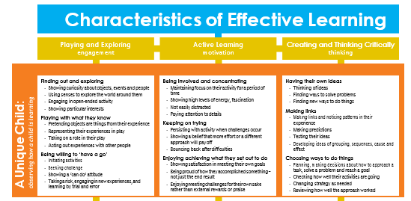
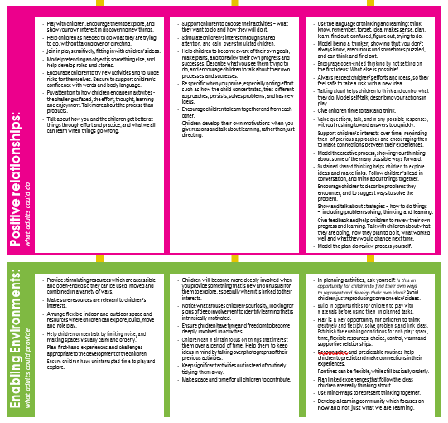
Appendix 4
Establishing Good Routines

Strong relationships between staff and pupils are vital. Staff must be fair and consistent with children (taking into account individual needs) and pupils must also understand that the staff member is in control at all times enabling the whole school community to feel safe. These expectations are reinforced through good routines in the classroom and for when the children are around the school.

Good routines should be in place for:
- Start of the day – a warm welcome from staff at the classroom door every day which also provides an opportunity for each child to feel valued, safe and secure in the sense of connection with the member of staff. For most children, this can be achieved by the simple acknowledgement of the child and the child having the knowledge that they are in mind. It will also allow staff to notice any potential difficulties a child any have in settling to learn that day.
- End of the day – to accommodate transition from school/home, allow for time organising things to go home and a definite farewell through a class saying, song or goodbye wish.
- Transition times – calm and ordered routines for coming in and out of the classroom, school, assemblies, change of lessons and so on.
- Lining up – clear guidance given for lining up and moving around the school.
- Getting changed for PE – children expected to change quickly and quietly with clear guidance on where to store clothes/kit.
- Moving around the school – calmly walking to the left around corridors, opening doors for adults, using good manners, waiting for people in front of you and so on.
- Break and lunchtimes – clear guidance on expectation of not coming back into class unsupervised, how to move around/on/off the playground, how to enter/leave the dining hall and expectations of dining hall conduct.

Appendix 5- The Restorative/Repair Conversation

You will find a selection of questions below to use in your restorative meeting. These can be written on ID card so they are there for easy reference. Five questions is enough, foundation children will only manage two or three questions- you know our children, so go with their need and what they can manage.
- What happened?
- What were you thinking at the time?
- What have you thought since?
- How did this make people feel?
- Who has been affected?
- How have they been affected?
- What should we do to put things right?
- How can we do things differently in the future?

Take your time with these meetings, allow up to 15 minutes, to give it the value you need.

- Try to get them to imagine it differently.
- Scaling with them- on a scale of 1-10 how angry were you?
- Offer a postponement and some support if the child is not ready to talk at that point, be clear to set a date with them the next day though.

Appendix 6 – SL to include Behaviour Log

